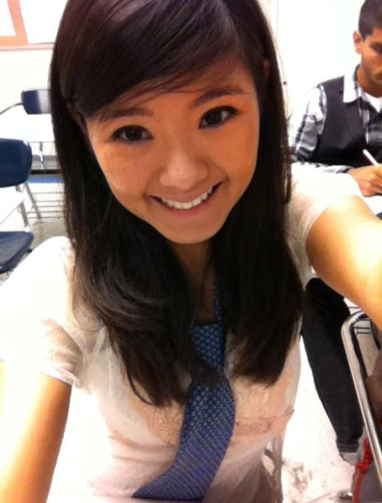
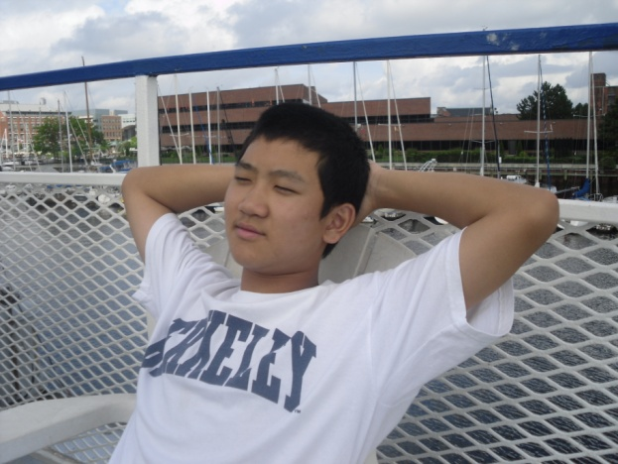
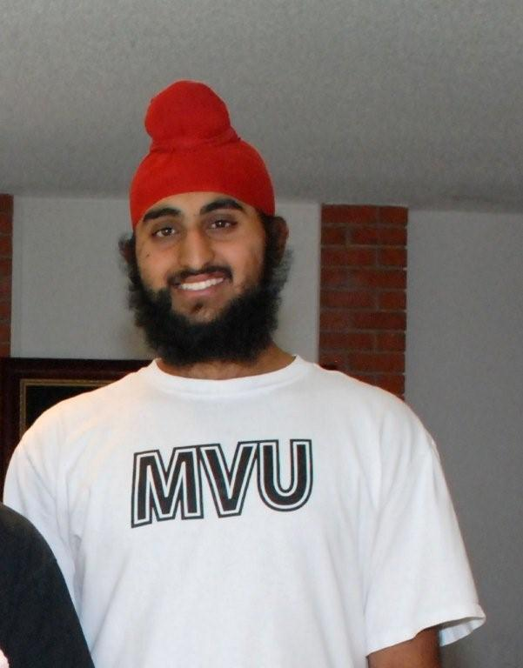

Alexis Lee

I first became interested in robotics after I watched my favorite movie, Wall-e. Since then, I have been with the Irvington Robotics Team at the beginning of my junior year. I’ve always enjoyed working with my team members because we’ve always been able to work successfully with each other, despite any minor conflicts that have happened. My favorite aspect about working with the robot is coming up with new, innovative ideas about how things should be built for maximum efficiency.

Eugene Fung

My name is Eugene Fung and I am a senior at Irvington High School. I joined robotics club when I was a freshmen and I have continued participating in robotics for the last three years. In sophomore year I competed in Botball, then in junior year I competed in FTC. I joined robotics because I had interest in learning about programming and building robots. I have two sisters who have graduated college. In my free time I like to play tennis, basketball, and ice hockey. My favorite books are Catcher in the Rye, Death of a Salesman, and Adventures of Huckleberry Finn.

Joraaver Chahal

I am 17 years old and a senior at Irvington High School. I have always been interested in robotics; I got the Lego Mindstorms NXT kit when I was 10, and I have 3 kits now. In fact, I've won a couple online contests involving Mindstorms NXT (even though no prize was involved). When I went to Legoland as a kid, I would always do the RCX robotics class they had, even if I had already done it. My father took me to see an FLL tournament too, which sparked my interest in the competitive side of robotics. As a freshman in Irvington, I took the intro to Robotics class after school to get a little more serious with my hobby. I also joined up with the local FRC team, 2489 (the Insomniacs). However, to be really involved with the team took too much of my time. However, as a sophomore, I did Botball, and had a lot of fun building and competing as a team. This year, FTC gave me a chance to get involved again with the FIRST community and work with the team around my schedule, giving me time to get my hands dirty with something I love to do. But robotics, although seemingly true, isn't my only hobby. I juggle a lot, play soccer for the varsity team, and enjoy hanging around with my friends, whether it be at school or at my house, duking it out on Modern Warfare 2 after meetings.

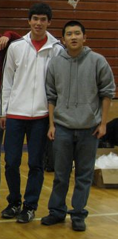
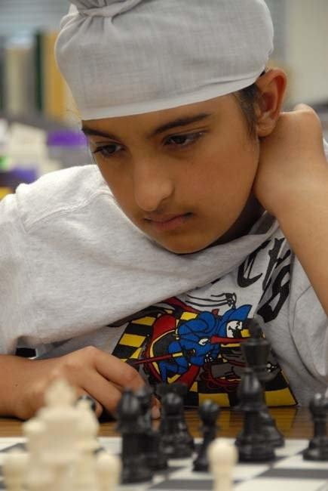
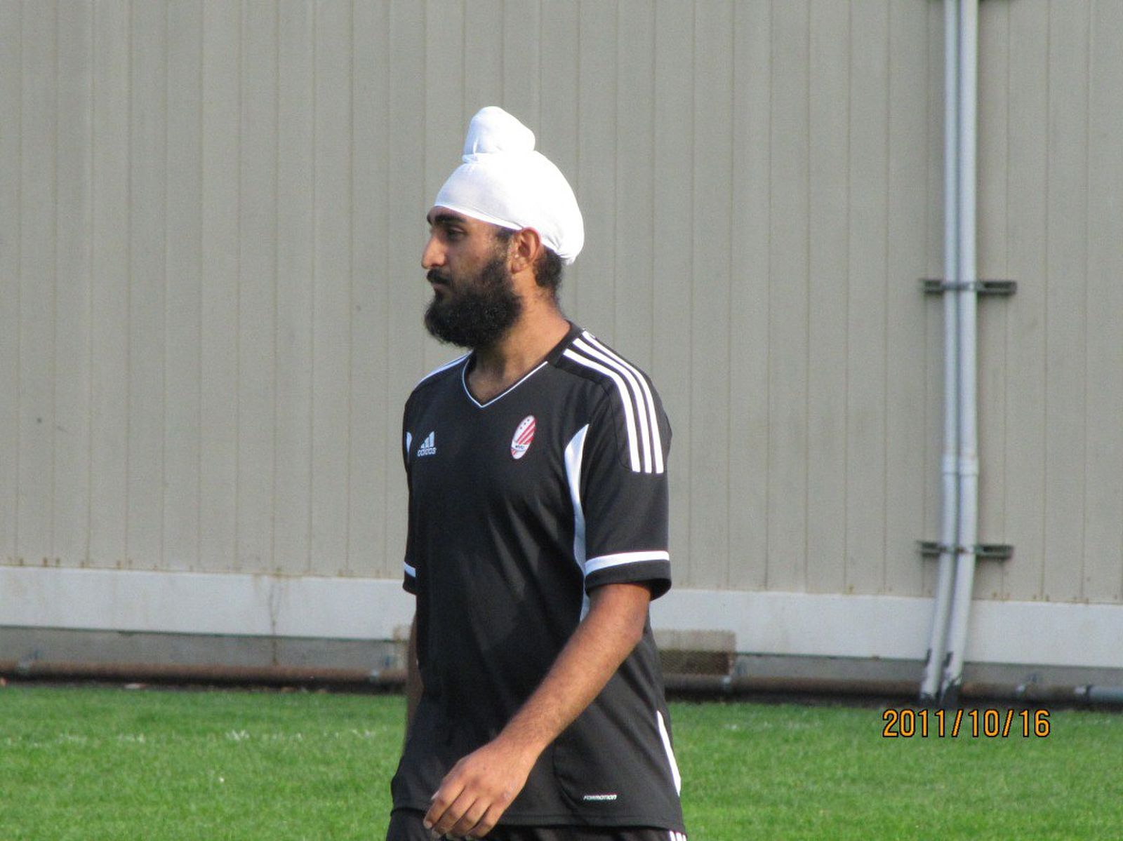
Suchaaver Chahal

I am 17 years old and a senior at Irvington High School. I have and identical twin, whom you will notice is also on this team, and a little brother (who is also on this team). I've been interested in robotics since I was a child; I believe most of this interest developed when my family watched Battle Bots together on TV. They also showed me an FLL competition, and although I never competed in middle school, my interest never swayed. So upon entering Irvington, I joined the Robotics Club. In 9th grade, I took a robotics course after school, and in 10th grade I competed in Botball. FTC seemed like another good competition to join, and remembering what the FLL competition, I was eager. So here I am. But robotics is not my only source of enjoyment. I also play soccer. Some of my other interests include film making, physics, amateur astronomy, and anatomy.

Robert Kurihara

I joined the Irvington Robotics team on a whim in junior year. I decided to follow Joraaver and Suchaaver to the first meeting, and I soon found my passion for robotics. Although I had little experience with robots when I first started out, my experience with legos allowed me to learn quickly. One year later, I have become a co-programmer for the Red Holorams and hope to continue to contribute innovative ideas to our team.

Amarinder Chahal

I am 13 years old, starting 8th grade in Horner Jr. High, and starting FTC. When I was seven years old, my parents got me a Mindstorms NXT set for my birthday. I fell in love with that toy, even though I did not know what it was fully capable of. My older brother showed me the ropes, but after that, I had to make the bridges. Still, while he excelled in winning a few online competitions, I was busy with my own creative masterpieces. While my creations could not come close to the excellence of his, I was determined to match his skills. Now, almost six years later, I have come close. Yet, I was not obsessed with proving my abilities to myself. Last year, I participated in the FLL competitions held for schools and local teams. And I won, as captain of a team with my seventh-grade friends. Thus, I proved to myself that I was ready to take the next step. Furthermore, there is a new game, new rules, but the same FIRST community. It fascinates me to watch experienced FRC teams battle each other on the crowded field. Despite my love for robotics, I also have other hobbies. My friends and I enjoy playing basketball or soccer, and in my spare time, I affiliate myself with something familiar—programming apps for Apple's app store. With some luck, I hope to reach the professional levels of computer programming.

